Software Specifications Document (SSD)
Entity Enhancement

Profile
Title | Conversion for Customer Master List
Tracking #
Product Line
Product Line |  |  |  | Style Master conversion
Module(s) | Sales Rep Module
Entity Type
Entity(s) | 1
Customer | Cam09 (Camp David )
Date Created | 06/22/2005
Author | Samah Mechael
Date Edited | 06/22/2005
Editor
Analysis | Approved By
Analysis | Approval Date |  | MM / DD / YYYY
Conceptual Design | Approved By
Conceptual Design | Approval Date |  | MM / DD / YYYY
Detailed Design | Approved By
Detailed Design | Approval Date |  | MM / DD / YYYY

Table of Contents
Profile 1
Table of Contents 2
Document Sections 3
Versions 3
Vision 4
Stakeholders 4
Needs 5
CFN – Customer Functional Needs 5
CTC – Customer Technical Needs 5
AFN – Aria Functional Needs 5
ATC – Aria Technical Needs 5
ATT – Aria Testing Needs 5
AMT – Aria Marketing Needs 5
ADT – Aria Documentation Needs 5
AST – Aria Supplementary Needs 5
Project Scope 5
1. In/Out Domains 5
2. Project Phases 5
Entity Features 6
User Interface (UI) 6
Option Grid 6
Use Cases 6
UI Rules 7
Option Grid Rules 7
Application Tier 8
Database Design 9
Testing Cases 9

Document Sections
Analysis
Vision
Stakeholders
Needs *
Customer Functional Needs
Customer Technical Needs
Aria Functional Needs
Aria Technical Needs
Aria Testing Needs
Aria Marketing Needs
Aria Documentation Needs
Supplementary Needs
Project Scope
Conceptual Design
Entity Features
User Interface (UI)
Option Grid
Use Cases
Detailed Design
UI Rules
Option Grid Rules
Application Tier
Database Design
Testing Cases
* At least one of the two functional needs sections must be filled.

Versions
Ver # | Date | Modified By | Sections Change Tracking
Ver # | Date | Modified By | New | Deleted | Changed
0.1 | 06/22/2005 | Samah Mechael

Vision
We need to convert the vendor master list sent to us from Camp David to Aria data
Stakeholders
Role | Category | Description | Comments
Aria users in CampDavid | User

Needs

CFN – Customer Functional Needs
Camp David Inc needs to convert the data for the Sales rep information from MAS90 to Aria Data

AFN – Aria Functional Needs
- The mapping for the fields will be listed in the Entity features section
- Division codes will read from the division master file attached below
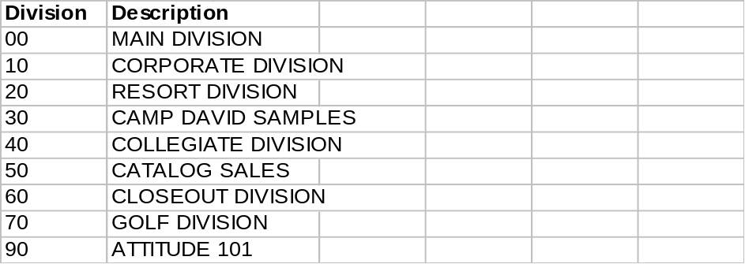

Entity Features

List of the fields mapped between the old and new files
Aria File | Aria field | CampDavid File | CampDavid Field
Salesrep | RepCode | SalesPerson master File | - SalespersonNumber  - We have to trim the 1st zero in the S/R # , even with that there will be still 4 records has to be handled manually  - We will take into consideration that the same repcode is repeated for multiple division , so we will added it only once in this file
Salesrep | Name | SalesPerson master File | Name
Salesrep | caddress1 | SalesPerson master File | AddressLine1
Salesrep | caddress2 | SalesPerson master File | AddressLine2
Salesrep | caddress3 | SalesPerson master File | City
Salesrep | caddress4 | SalesPerson master File | State
Salesrep | caddress5 | SalesPerson master File | ZipCode
Salesrep | caddress6 | SalesPerson master File | CountryCode
Salesrep | cemail_add | SalesPerson master File | EmailAddress
Salesrep | Phone | SalesPerson master File | TelephoneNo
Rep_Div | RepCode | SalesPerson master File | SalespersonNumber
Rep_Div | Cdivision | SalesPerson master File | Division
Rep_Div | comm_rate | SalesPerson master File | CommRate

User Interface (UI)
[Show the system UI modifications here, if any. Otherwise omit this section. This if used must include screens/reports prototypes.]

Option Grid
# | Item | Operator | Value

Use Cases
Scenario | Step # | Description | # | User Actions | System Action
 | 1 |  | 1
 |  |  | 2
 |  |  | 3
 | 2 |  | 1
 |  |  | 2
 |  |  | 3

UI Rules
Ser. | Screen Object | Attribute | Value
1 |  | Description
 |  | Control Type
 |  | Source
 |  | Caption
 |  | Visible | [default is True]
 |  | Enabled | [default is True]
 |  | Mandatory | [default is False]
 |  | Tab Sequence
 |  | Default Value
 |  | List of Values (LOV) | [usually by having a list button that calls a lookup file]
 |  | Validations
 |  | Post-Object Processing | [Actions to be done with a certain event (button pressed, field exited, list option selected…etc)]
 |  | … | [Add any additional attributes you need]
2

Option Grid Rules
Ser. | Grid Item | Attribute | Value
1 |  | Description
 |  | Control Type
 |  | Default Value
 |  | Action
 |  | Source
 |  | Browse fields
 |  | Validations
 |  | Suppress condition
2

Application Tier
- Class Description

- Class Responsibilities

- Relationships with Other Classes:

Related Class | Based on | Depends on | Uses
- Special Requirements

- Class Interface (Properties/Controls/Methods/Events)
Properties:
# | Name | Description | Data Type
Class Controls:
# | Control Name | Description | Init Properties
Methods:
# | Name |  |  | Description
1
 | Method Signature
 | Parameters |  |  |  |  |  | Return
 | # | Name | Description |  | Opt | Default | Value | Condition
2
 | Method Signature
 | Parameters |  |  |  |  |  | Return
 | # | Name | Description |  | Opt | Default | Value | Condition
Events:
# | Control Name | Control Event | Action

Database Design
[Describe the system database modifications here, if any. Otherwise omit this section.]

Testing Cases
Test Setup:

# | Test Settings
1
2

Test Cases:

Test | Repeat by Setting | Test Actions | Test Results | OK

